https://app.ringcentral.com/login
RingCentral

click Fax Icon
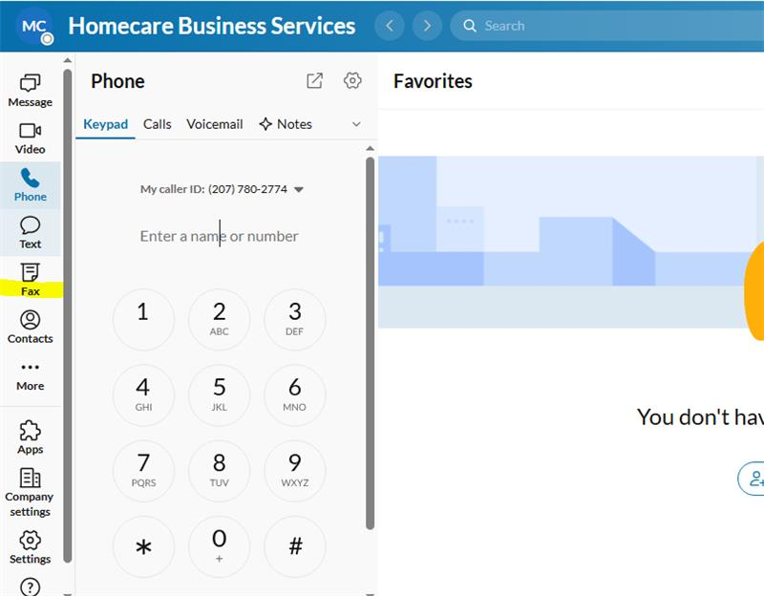

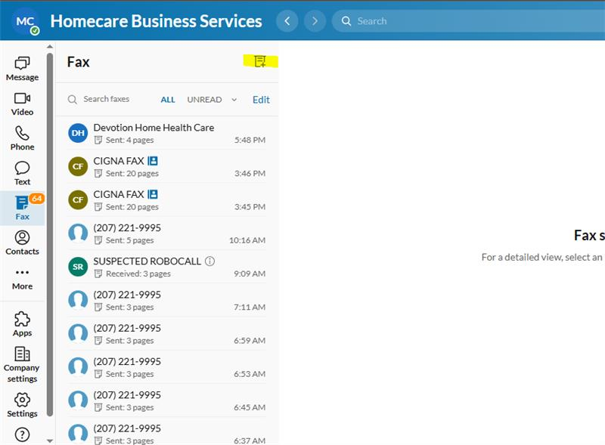
click Send new fax button

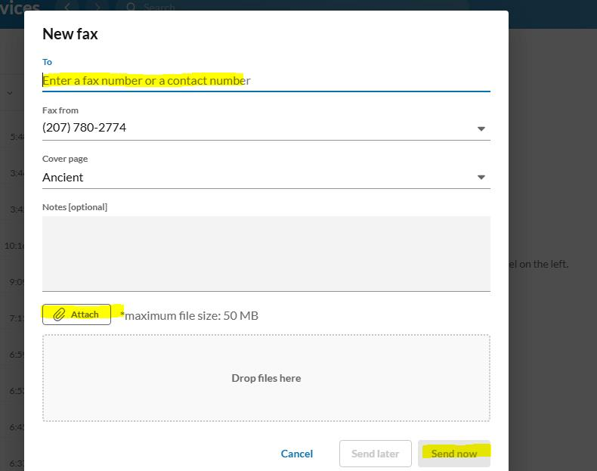

Add Devotion Fax number, attach the file to be sent, click send now button

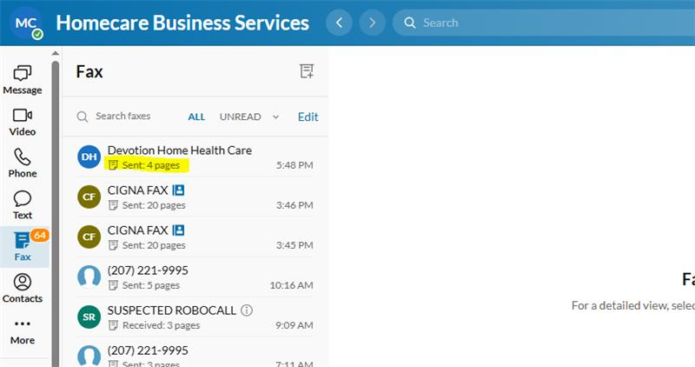

Status of the fax will be shown here

approximately 30 to 45 minutes before the fax will reflect on Devotions received fax list..

