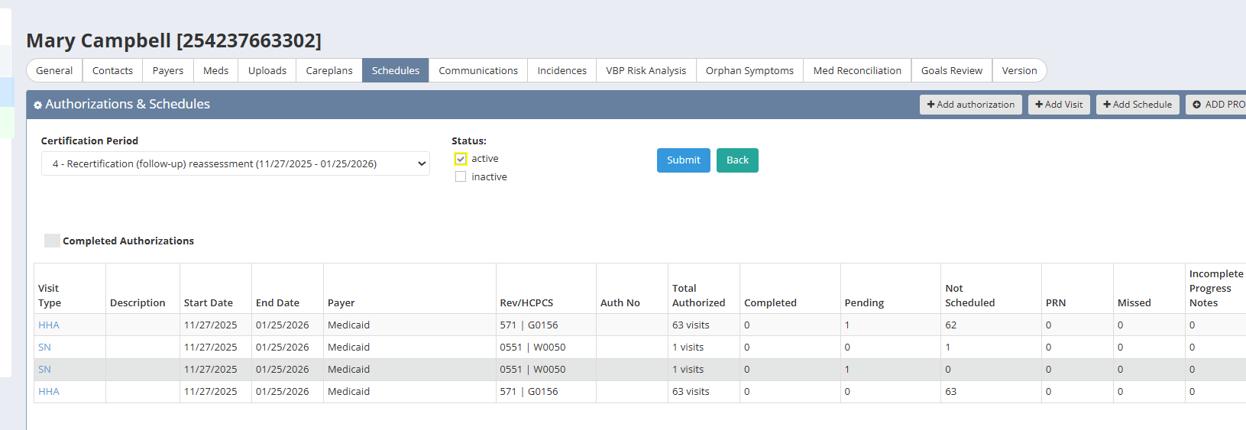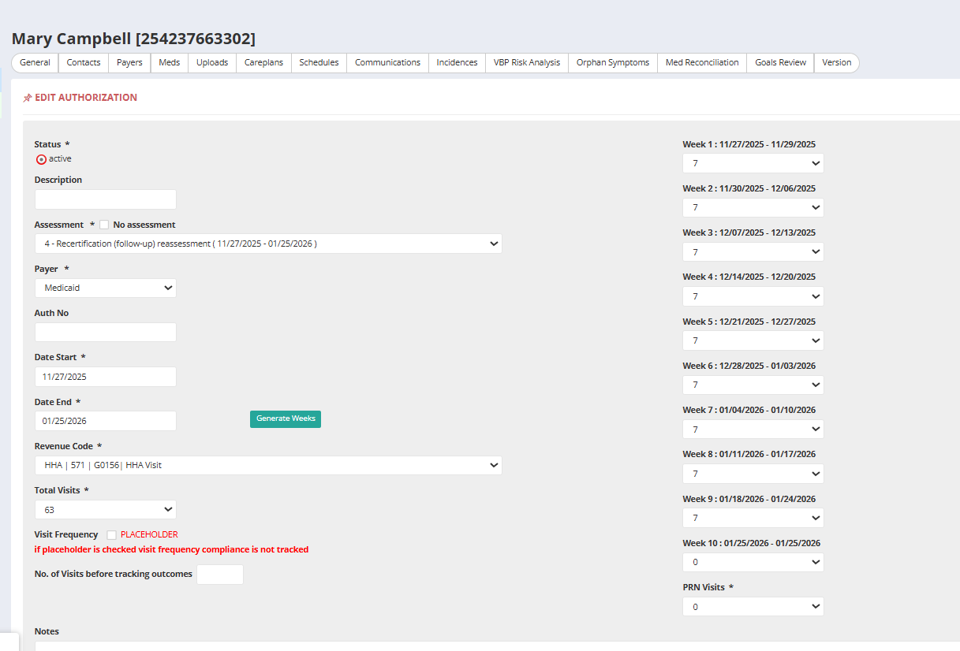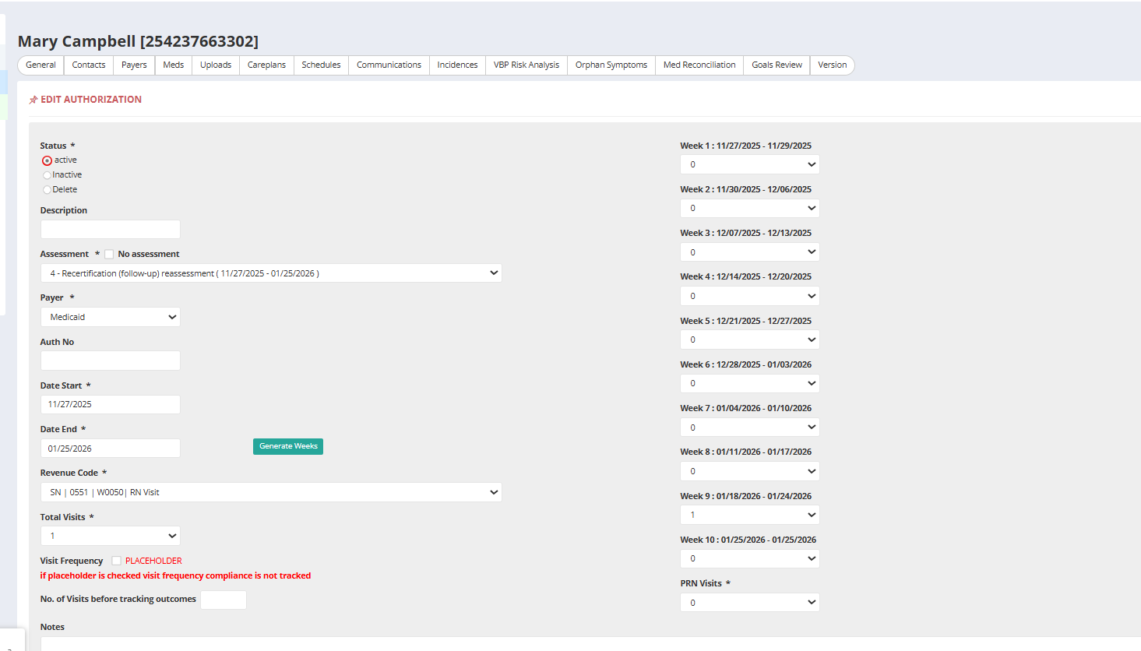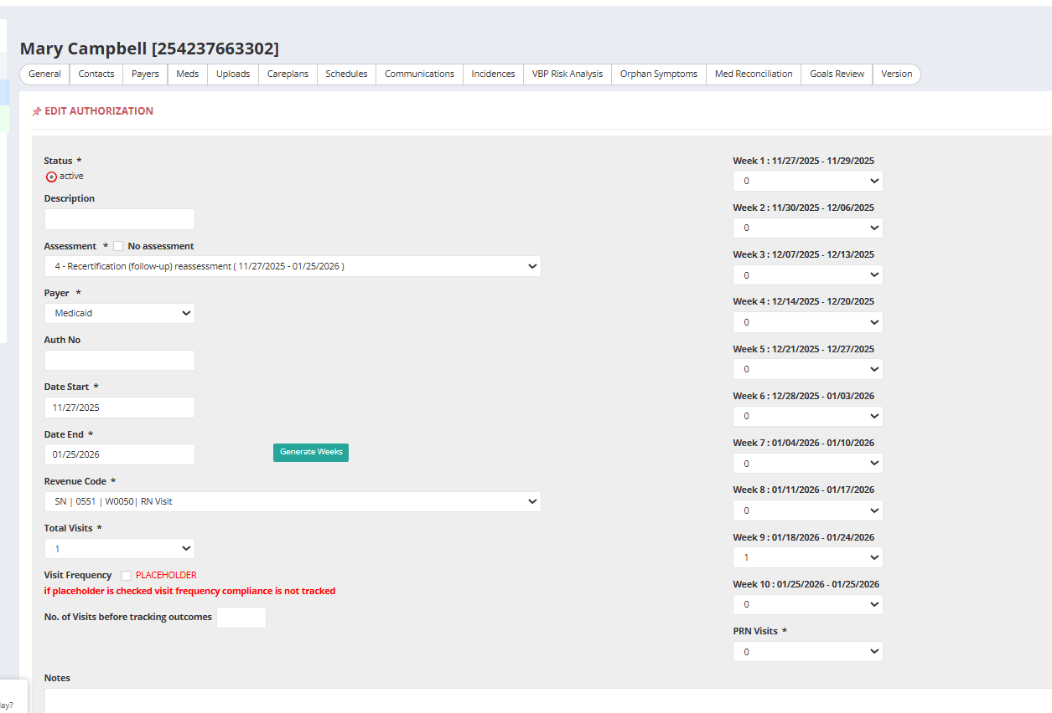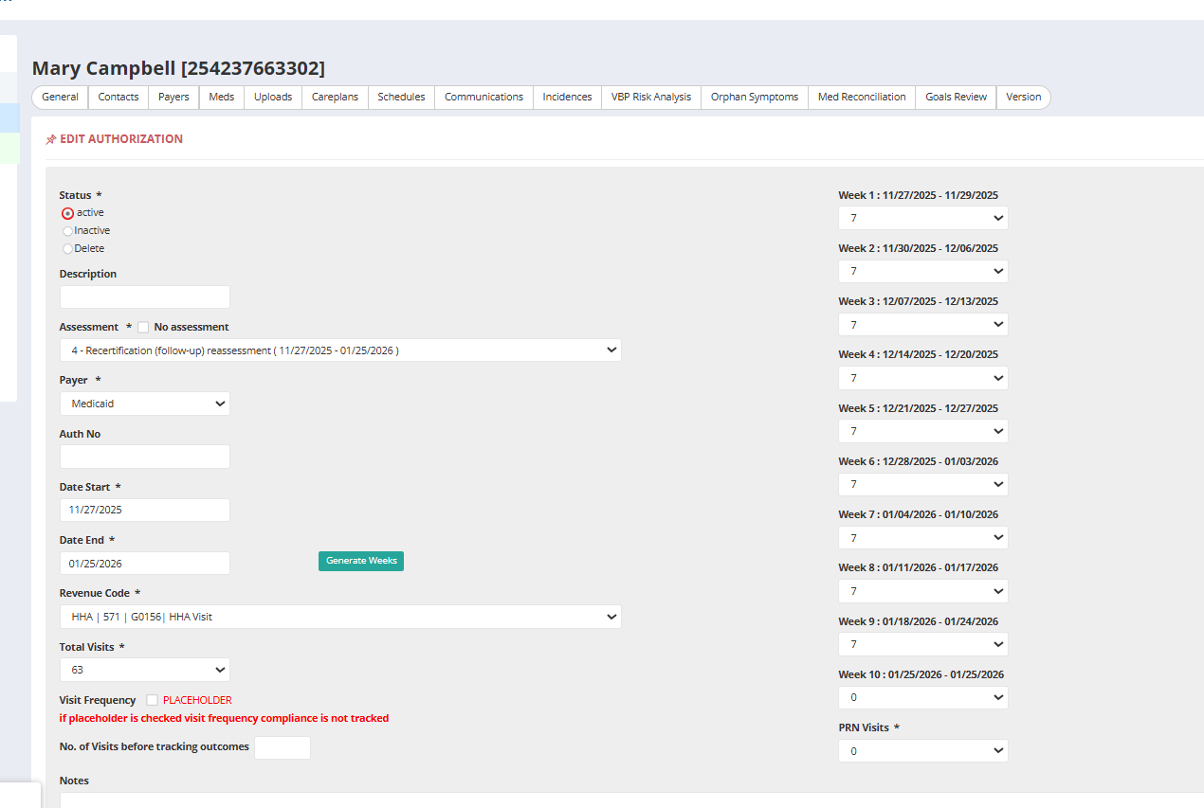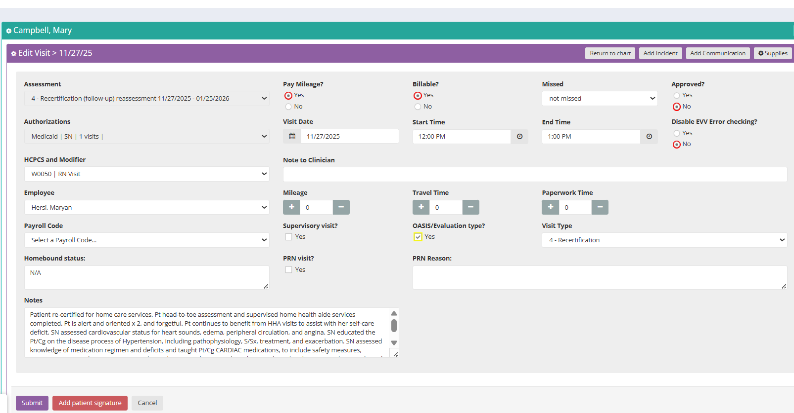Patient re-certified for home care services. Pt head-to-toe assessment and supervised home health aide services completed. Pt is alert and oriented x 2, and forgetful. Pt continues to benefit from HHA visits to assist with her self-care deficit. SN assessed cardiovascular status for heart sounds, edema, peripheral circulation, and angina. SN educated the Pt/Cg on the disease process of Hypertension, including pathophysiology, S/Sx, treatment, and exacerbation. SN assessed knowledge of medication regimen and deficits and taught Pt/Cg CARDIAC medications, to include safety measures, purpose, action, and S/E. Nurse assessed pain this visit and instructed on Pharmacological and Non- non-pharmacological pain management. Patient reported Generalized pain/ weakness, joint pain. 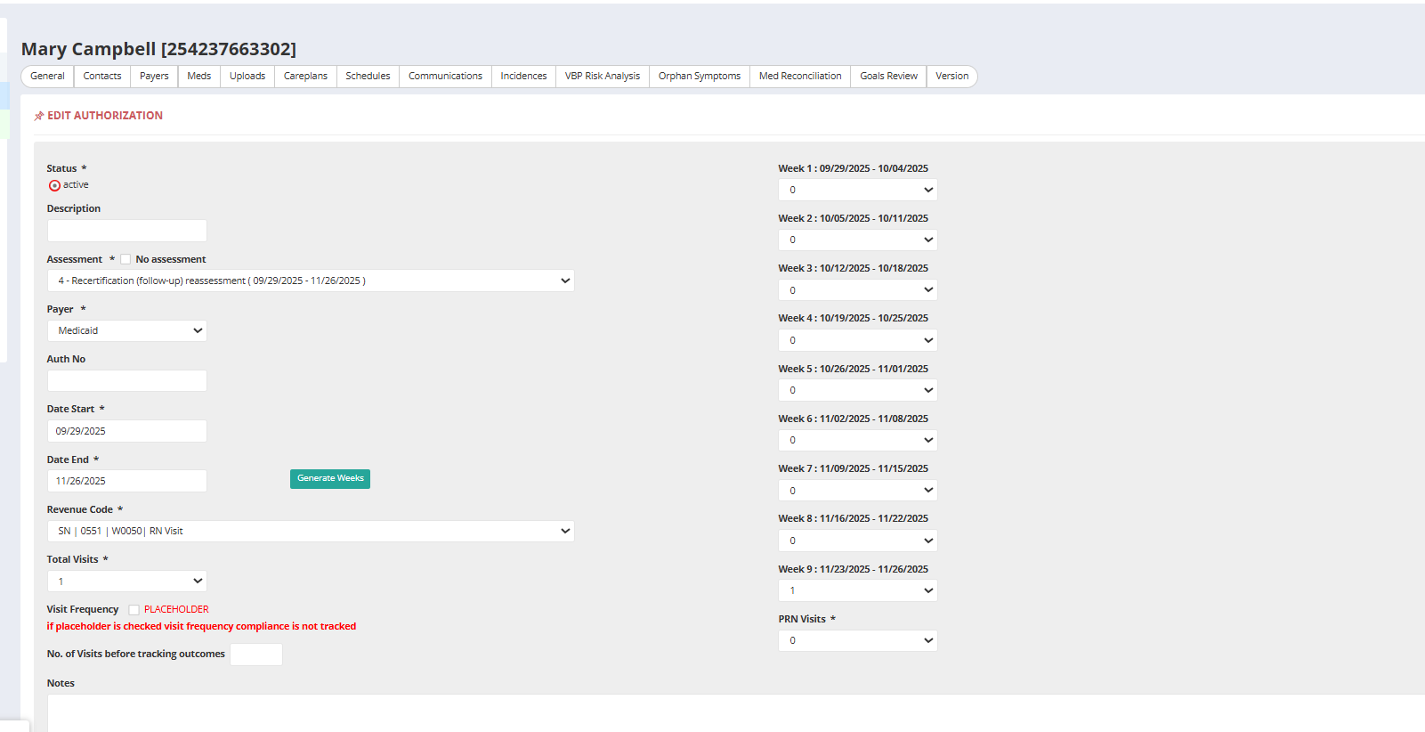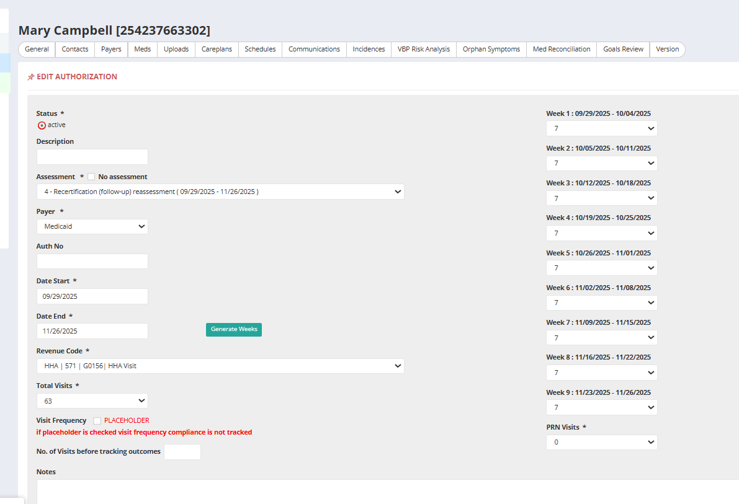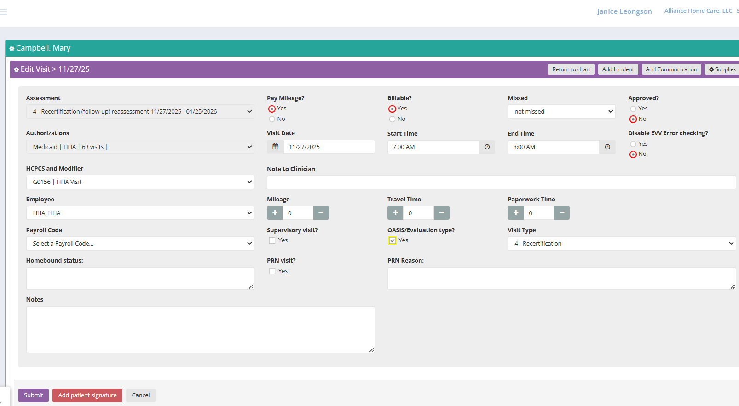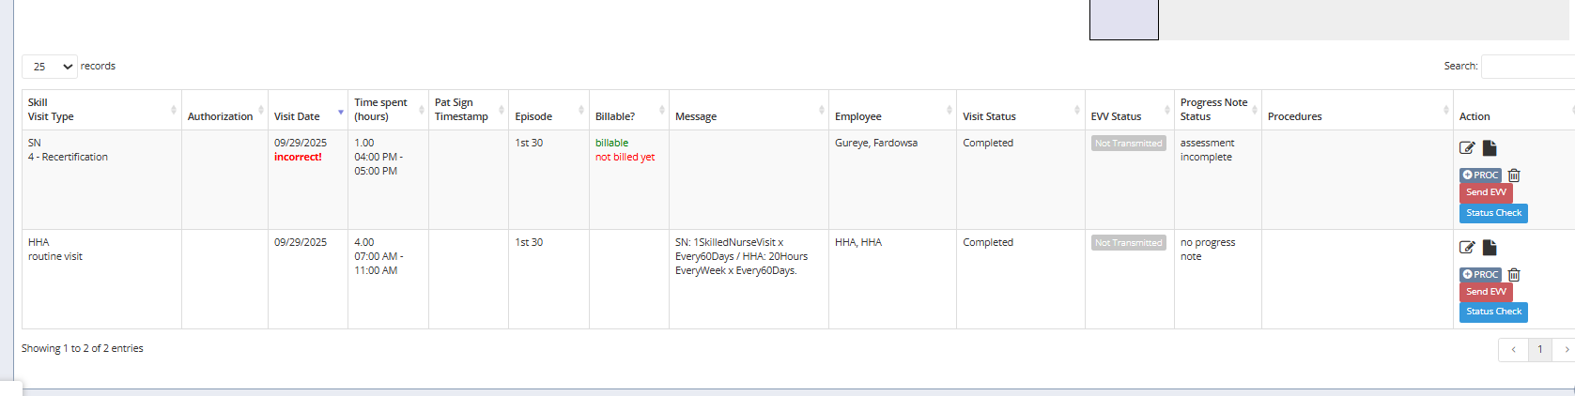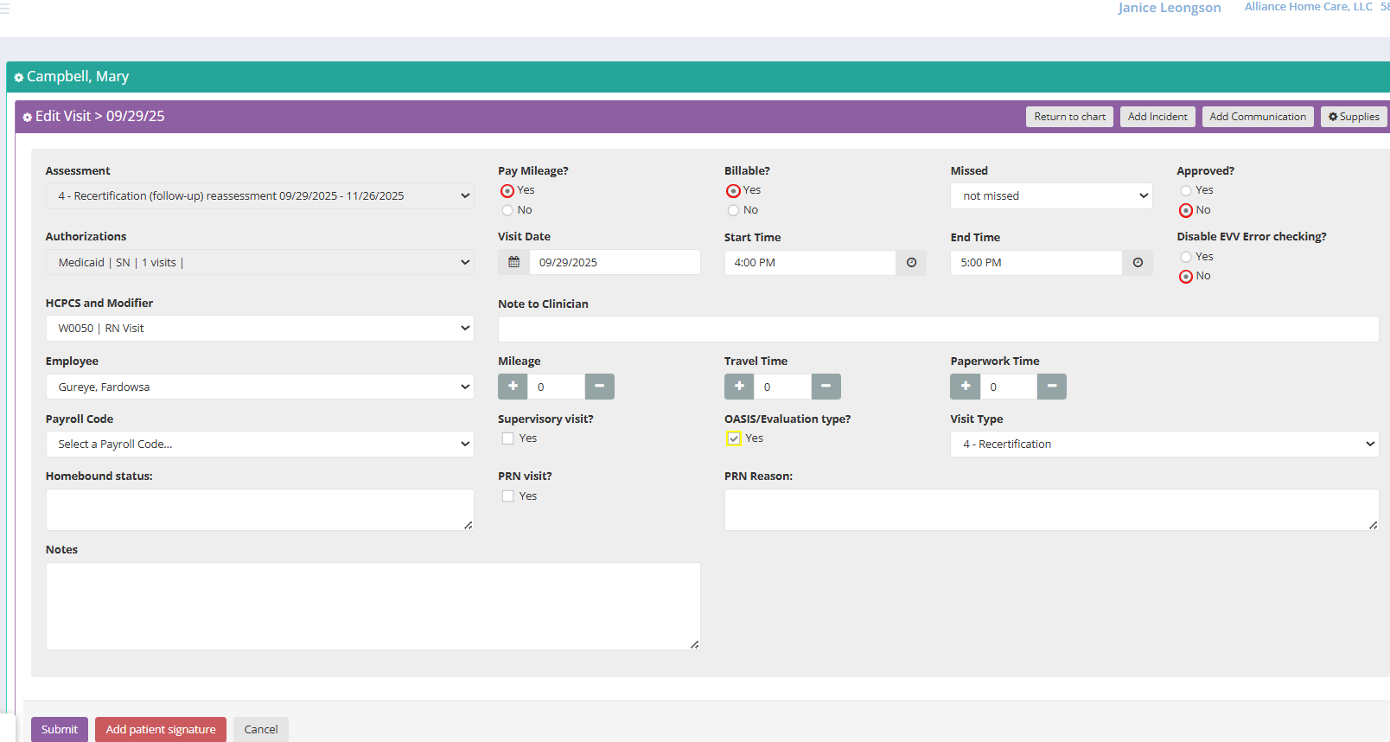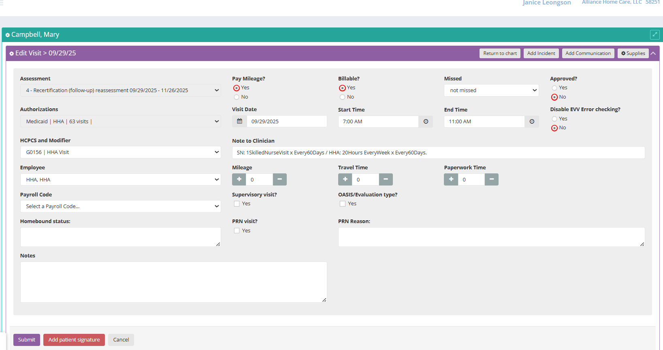SN: 1SkilledNurseVisit x Every60Days / HHA: 20Hours EveryWeek x Every60Days.

